**CAP 454: LINUX AND SHELL SCRIPTING - LABORATORY**

**CONTINUOUS ASSESSMENTS (C.A)-4**

**ST_NAME: - EKHLAKH AHMAD**

**REG NO.: - 12209166**

**ROLL NO.: - RD2215B67**

**SECTION: - D2215**

**GROUP: - 2**

**Q.1. Connect APACHY server.**

**Process: -**

* Open VMWare software.
* And open Linux terminal.
* Install httpd packet for apachy.
* Connect CD mount and select httpd.
* 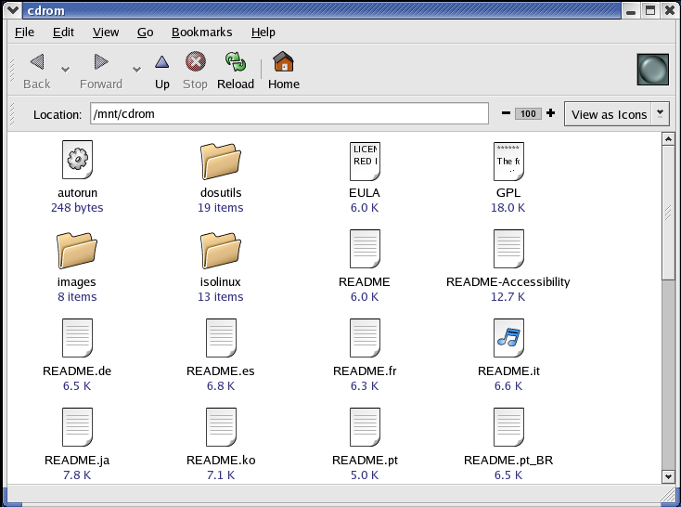Open terminal and type rpm -ivh package name.
* check package install or not.
* Type command “rpm -q package_name”.
* 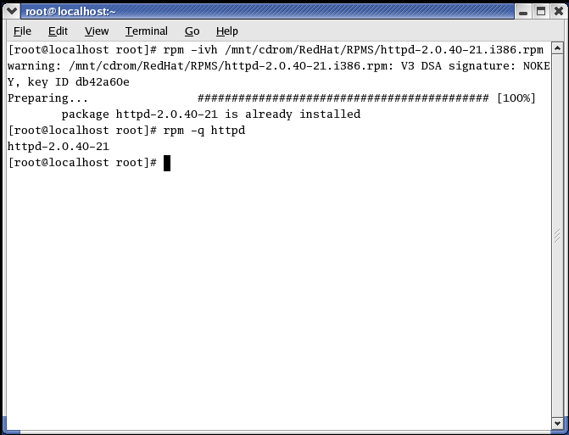Then press Enter key.
* Again open terminal and create directory and enter file inside directory.
* Type some text.
* Then give file permission
* All permission this command chmod 777 file path.
* And start service “service httpd start”.
* Close the terminal.
* Go to web browser.
* Then type <http://localhost>.
* Then press Enter key.

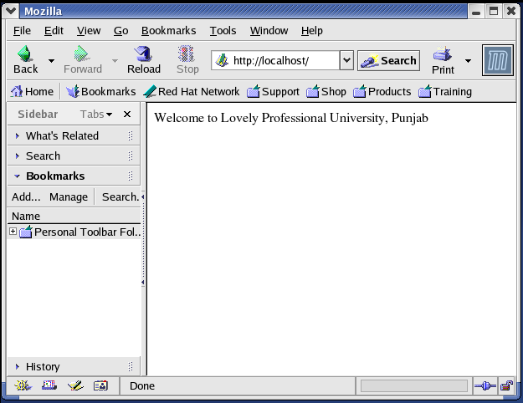

**Q.2. Connect FTP server.**

**Process: -**

* Open VMWare software.
* And open Linux terminal.
* Install vsftpd package.
* CD mount and connect CD.
* Select vsftpd packet.
* Again, open terminal.
* Type “rpm -ivh package_Name”.
* Then press Enter key.
* And check packet install or not.
* This command “rpm -q vsftpd”.

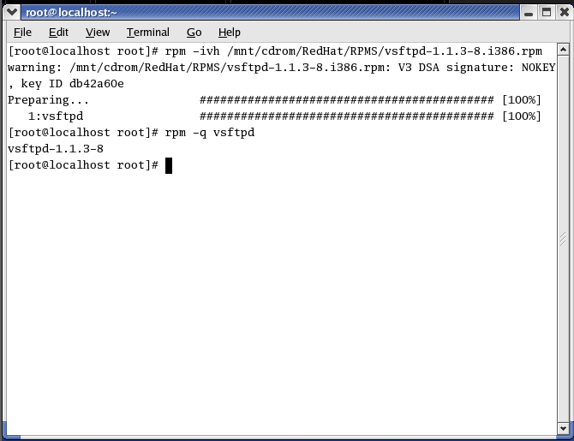

* Change configure file.
* Open terminal and type “redhat-config-packages”.
* 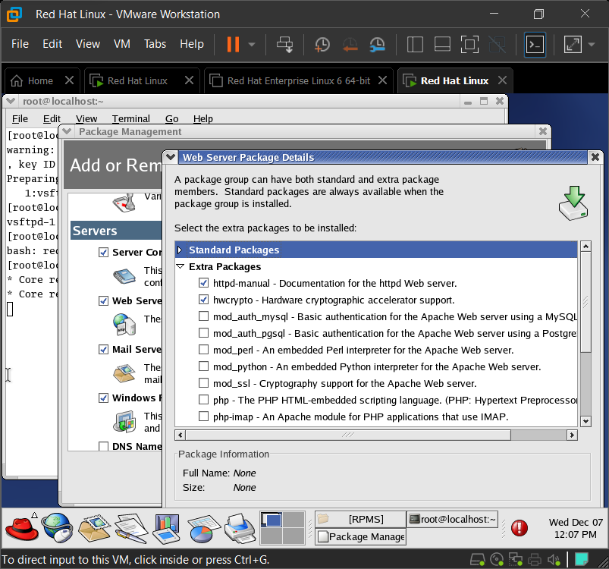Select two check option button and save quite and apdate.
* Service vsftpd start.
* Check IP ADDRESS and Press Enter key.
* Check IP command “ip addr show”.
* Start FTP server.
* This command #ftp ip 192.168.11.162 then press enter key.
* Enter User name.
* Type password.

